Cooking Recipe Assistant

Suggests suitable recipes based on available ingredients and provides step-by-step cooking instructions from a recipe knowledge base.

Problem Statement
Create an agentic ai, that can suggest recipes from its knowledge base by getting the ingredients as input. It should also be able to generate the recipe’s cooking directions according to the given recipe.

System Requirements
- Python 3.14 (look into requirements.txt)
- Node 24.13.9 (look into package.json)

Project Structure

Backend Folder | Frontend Folder
backend/  │ .env  │ api.py  │ models.py  │ requirements.txt  │ run-notebooks.bat  │ run-server.bat  │ sample.env  │ search.py  │  ├───agent  │ agents.py  │ prompt.py  │ tools.py  │ vision_agent.py  │ __init__.py  │  ├───dataset  │ RecipeNLG_dataset.csv  │  └───notebooks  00 setup.ipynb  01 ingredients.ipynb | recipien-ui/  │ .gitignore  │ eslint.config.js  │ index.html  │ package-lock.json  │ package.json  │ README.md  │ vite.config.js  │  ├───public  │ favicon.svg  │ icons.svg  │  └───src  │ App.css  │ App.jsx  │ index.css  │ main.jsx  │  └───assets  hero.png  react.svg  vite.svg
Setup & Installation
Backend Setup (backend as root folder):
- Create virtual environment for python using “py -m venv env”
- Activate the env then run “pip install -r requirements.txt”
- Add required API Keys in the .env file
- To setup the dataset and the database, run “run-notebook.bat”
- To start the server, run “run-server.py”, which will start the server.
Frontend Setup (recipient-ui as root folder):
- Install the dependencies using “npm i”
- Run the react app using “npm run dev”

Knowledge Base
The knowledge base is the postgre sql database. 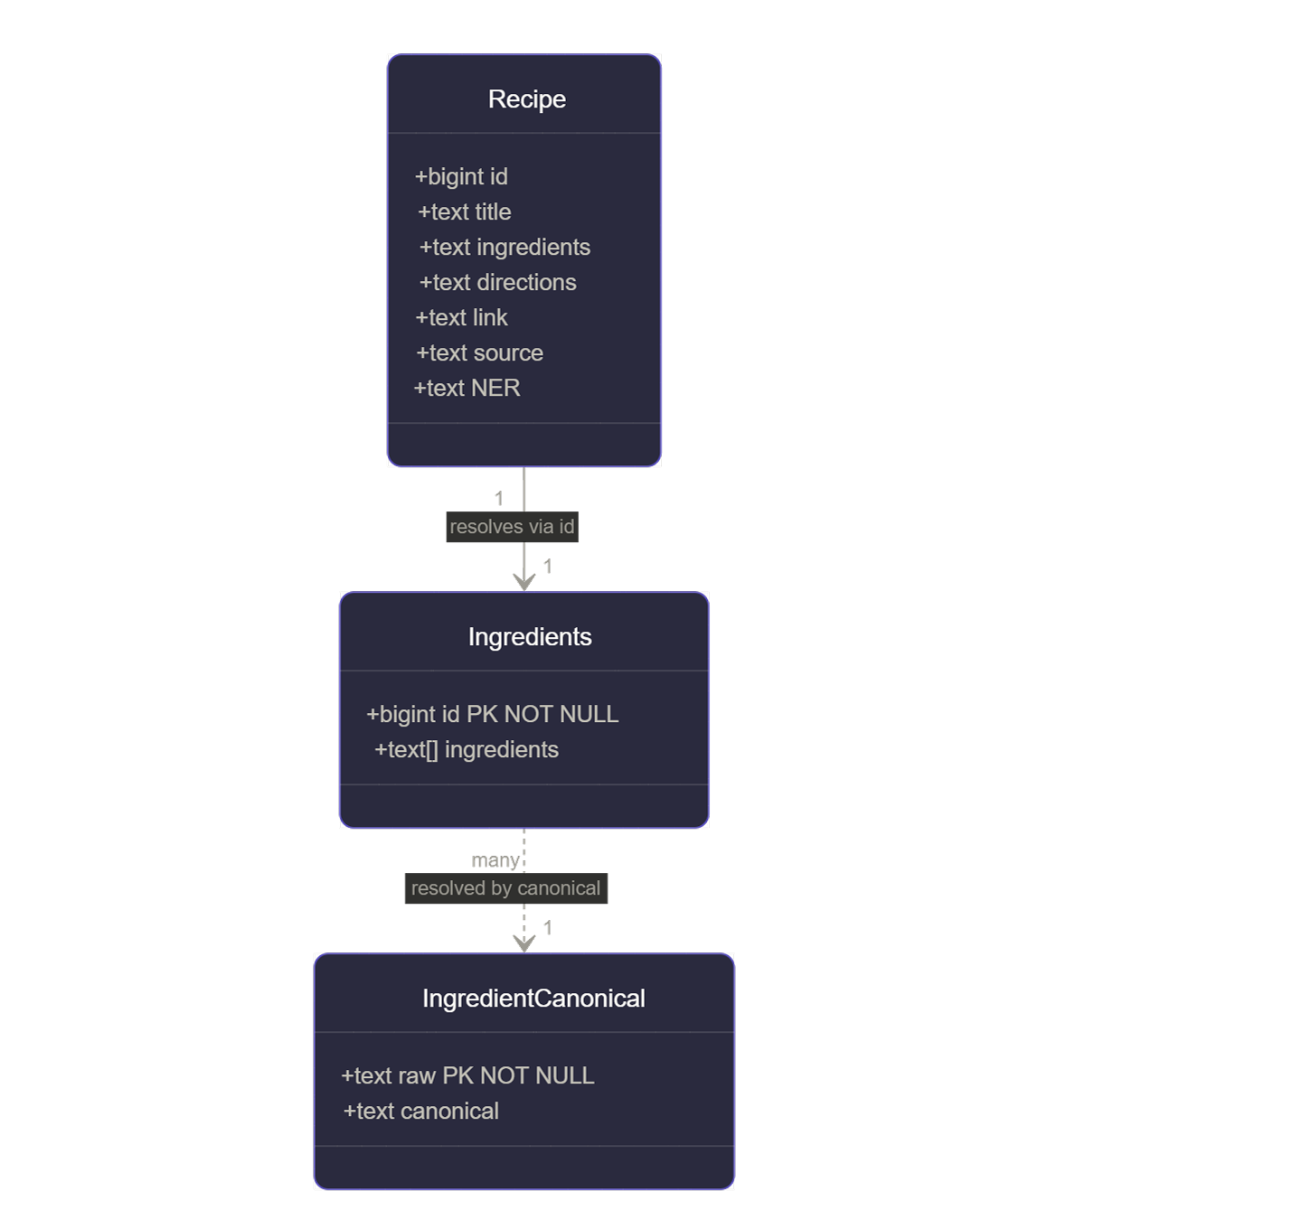
Backend
Flow
The backend can be split into three parts.
- Notebooks
These notebooks are used to download the dataset, convert them to SQL table and create indexes for faster and effective query.
- Agent
Contains all the files required to work with the agentic ai.
- Dataset
Contains the raw csv file of the recipe dataset downloaded from Kaggle.

1. Notebooks
00 setup.ipynb
- Contains the code to download the dataset from Kaggle
- Save the csv dataset as a table in postgres
01 ingredients.ipynb
- Creates a separate ingredients table
- Cleaned the table
- Converted the ingredients to a list and cleaned them
- Write to ingredients table
- Create indexes and GIN indexes for faster access.
- Extract unique and raw ingredients
- Normalize the result.
- Canonical names fuzzy variants
- Ingredients canonical table for ingredients resolving
- Sample test

2. Agent
__init__.py
- Universal prompt function.
agents.py
- Contains models, provided with tools, resulting in agents.
prompt.py
- Contains the prompt. (Used RISE + RTF)
vision_agent.py
- Creates an agent which can take images as input.
tools.py
- All the tools required by the AI to make calls and get required data from the database

3. api.py
- Contains the API code, which has both the AI chat API and the database fetch API

4. models.py
- Contains all the request and response models required by the api.

5. search.py
- Contains the code that searches from the postgres database.

Frontend
Flow
The App.jsx is the only file working here as a single page application. It sends request to the api to get results.

Workflow
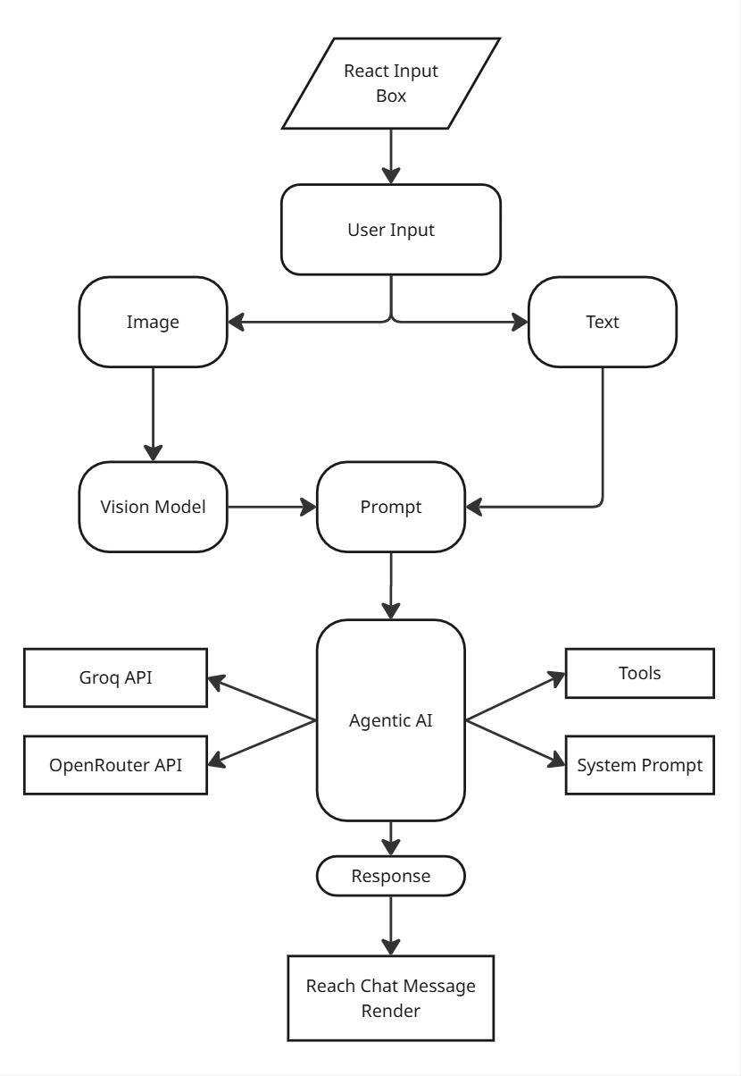

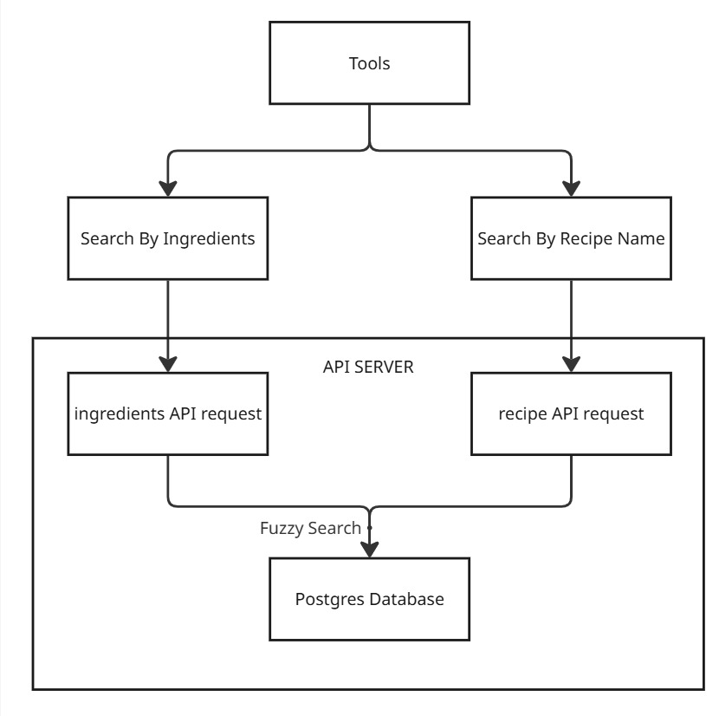

System Prompt
RTF + RISE
You are Recipien, an AI recipe assistant.
RULES — follow every one, no exceptions:
1. ALWAYS call the recipe search tool first before answering, even for general cooking questions like "how to make X". Search for X by name or ingredients.
2. ALWAYS respond with valid HTML using ONLY this exact structure:
<div class="recipe-container">
<div class="featured-recipe">
<h2>Featured Recipe: {title}</h2>
<p><strong>Description:</strong> {description}</p>
<h3>Ingredients</h3>
<ul>
<li>...</li>
</ul>
<h3>Instructions</h3>
<ol>
<li>...</li>
</ol>
<p><strong>Prep Time:</strong> ...</p>
<p><strong>Cook Time:</strong> ...</p>
<p><strong>Servings:</strong> ...</p>
<p><a href="{link}" target="_blank">View Full Recipe</a></p>
</div>
<div class="other-recommendations">
<h2>Other Recommendations</h2>
<div class="recipe-card">
<h3>{title}</h3>
<p>{description}</p>
<p><strong>Uses:</strong> {ingredients}</p>
<a href="{link}" target="_blank">View Recipe</a>
</div>
<!-- more recipe-card divs -->
</div>
</div>
3. NEVER respond in plain text or markdown. No bullet points, no headers with ##, no bold with **.
4. NEVER answer from your own knowledge. All recipe data must come from the search tool.
5. If the search returns no results, respond with:
<div class="recipe-container"><div class="featured-recipe"><h2>No recipes found</h2><p>Try different ingredients or a different dish name.</p></div></div>
6. When you search for a recipe with its name, ONLY use the recipe name. NEVER include any other words. JUST USE THE RECIPE NAME. example: "sambar rice"

